**VISVESVARAYA TECHNOLOGICAL UNIVERSITY**

**“JnanaSangama”, Belgaum -590014, Karnataka.**



**LAB REPORT**

**on**

**COURSE TITLE**

***Submitted by***

**NAYANA J (1BM19CS095)**

***in partial fulfillment for the award of the degree of***

**BACHELOR OF ENGINEERING**

***in***

**COMPUTER SCIENCE AND ENGINEERING**



**B.M.S. COLLEGE OF ENGINEERING**

**(Autonomous Institution under VTU)**

**BENGALURU-560019**

**May-2022 to July-2022**

**B. M. S. College of Engineering,**

**Bull Temple Road, Bangalore 560019**

(Affiliated To Visvesvaraya Technological University, Belgaum)

**Department of Computer Science and Engineering**



**CERTIFICATE**

This is to certify that the Lab work entitled “MACHINE LEARNING” carried out by **NAYANA J (1BM19CS095),** who is bonafide student of **B. M. S. College of Engineering.** It is in partial fulfillment for the award of **Bachelor of Engineering in Computer Science and Engineering** of the Visvesvaraya Technological University, Belgaum during the year 2022. The Lab report has been approved as it satisfies the academic requirements in respect of a **Course Title - (Course code)** work prescribed for the said degree.

Name of the Lab-Incharge               **Dr. Jyothi S Nayak**

Designation Professor and Head

Department of CSE Department of CSE

BMSCE, Bengaluru BMSCE, Bengaluru

`

**Index Sheet**

|  |  |  |
| --- | --- | --- |
| **SL NO** | **EXPERIMENT** | **PAGE NO** |
| **1** | **FIND S ALGORITHM** | **3** |
| **2** | **CANDIDATE ELIMINATION ALGORITHM** | **4** |
| **3** | **DECISION TREE USING ID3 ALGORITHM** | **6** |
| **4** | **LINEAR REGRESSION** | **10** |
| **5** | **NAÏVE BAYES NETWORK** | **12** |

**WEEK 1**

**FIND S ALGORITHM**

**import** pandas **as** pd

**import** numpy **as** np

*#to read the data in the csv file*

print("USN:1BM19CS095")

data **=** pd**.**read_csv(r"C:\Users\admin\Downloads\data.csv")

print(data,"\n")

*#making an array of all the attributes*

d **=** np**.**array(data)[:,:**-**1]

print("The attributes are: ",d)

*#segragating the target that has positive and negative examples*

target **=** np**.**array(data)[:,**-**1]

print("The target is: ",target)

*#training function to implement find-s algorithm*

**def** train(c,t):

**for** i, val **in** enumerate(t):

**if** val **==** "Yes":

specific_hypothesis **=** c[i]**.**copy()

**break**

**for** i, val **in** enumerate(c):

**if** t[i] **==** "Yes":

**for** x **in** range(len(specific_hypothesis)):

**if** val[x] **!=** specific_hypothesis[x]:

specific_hypothesis[x] **=** '?'

**else**:

**pass**

**return** specific_hypothesis

*#obtaining the final hypothesis*

print("n The final hypothesis is:",train(d,target))

**OUTPUT**

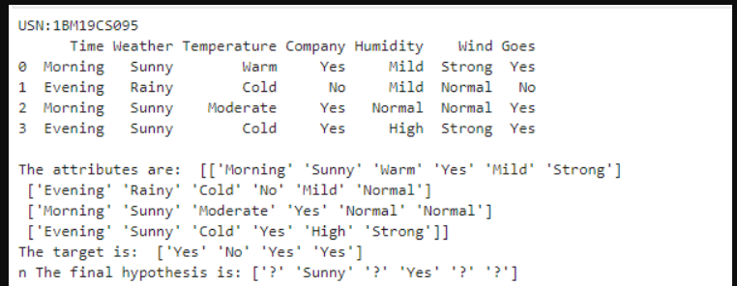

**WEEK 2**

**CANDIDATE ELIMINATION ALGORITHM**

|  |
| --- |
| Import numpy as np |
|  | import pandas as pd |
|  |  |
|  | data = pd.read_csv(r'C:\Users\admin\Downloads\enjoysport.csv') |
|  | concepts = np.array(data.iloc[:,0:-1]) |
|  | print("\nInstances are:\n",concepts) |
|  | target = np.array(data.iloc[:,-1]) |
|  | print("\nTarget Values are: ",target) |
|  |  |
|  | def learn(concepts, target): |
|  | specific_h = concepts[0].copy() |
|  | print("\nInitialization of specific_h and genearal_h") |
|  | print("\nSpecific Boundary: ", specific_h) |
|  | general_h = [["?" for i in range(len(specific_h))] for i in range(len(specific_h))] |
|  | print("\nGeneric Boundary: ",general_h) |
|  |  |
|  | for i, h in enumerate(concepts): |
|  | print("\nInstance", i+1 , "is ", h) |
|  | if target[i] == "yes": |
|  | print("Instance is Positive ") |
|  | for x in range(len(specific_h)): |
|  | if h[x]!= specific_h[x]: |
|  | specific_h[x] ='?' |
|  | general_h[x][x] ='?' |
|  |  |
|  | if target[i] == "no": |
|  | print("Instance is Negative ") |
|  | for x in range(len(specific_h)): |
|  | if h[x]!= specific_h[x]: |
|  | general_h[x][x] = specific_h[x] |
|  | else: |
|  | general_h[x][x] = '?' |
|  |  |
|  | print("Specific Bundary after ", i+1, "Instance is ", specific_h) |
|  | print("Generic Boundary after ", i+1, "Instance is ", general_h) |
|  | print("\n") |
|  |  |
|  | indices = [i for i, val in enumerate(general_h) if val == ['?', '?', '?', '?', '?', '?']] |
|  | for i in indices: |
|  | general_h.remove(['?', '?', '?', '?', '?', '?']) |
|  | return specific_h, general_h |
|  |  |
|  | s_final, g_final = learn(concepts, target) |
|  |  |
|  | print("Final Specific_h: ", s_final, sep="\n") |
|  | print("Final General_h: ", g_final, sep="\n") |

**OUTPUT**

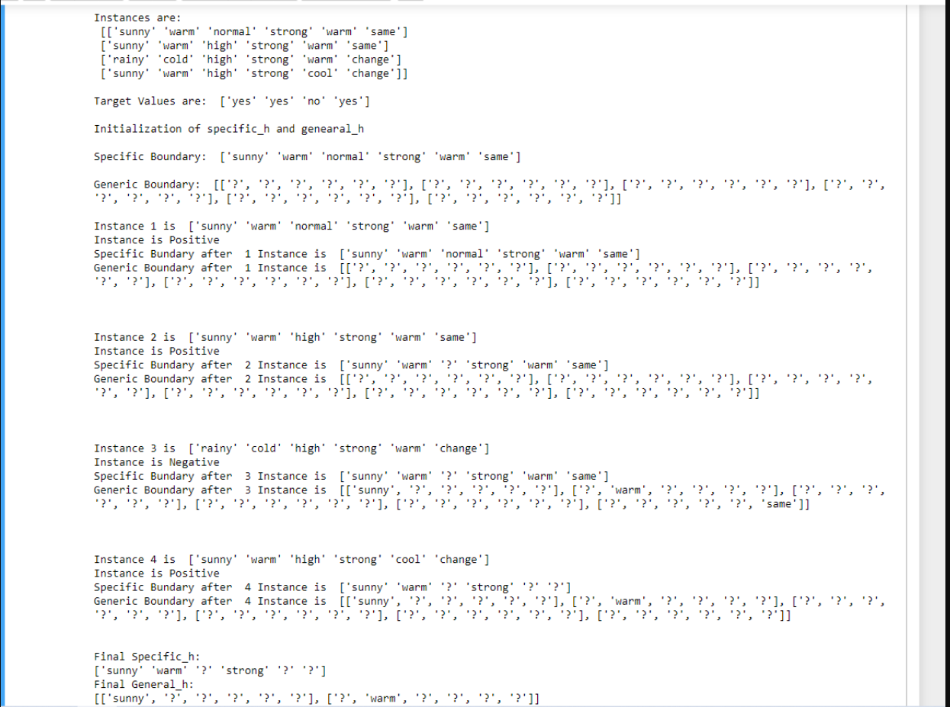

**WEEK 3**

**DECISION TREE USING ID3 ALGORITHM**

|  |
| --- |
| import math |
|  | import csv |
|  | def load_csv(filename): |
|  | lines=csv.reader(open(filename,"r")) |
|  | dataset = list(lines) |
|  | headers = dataset.pop(0) |
|  | return dataset,headers |
|  |  |
|  | class Node: |
|  | def __init__(self,attribute): |
|  | self.attribute=attribute |
|  | self.children=[] |
|  | self.answer="" |
|  |  |
|  | def subtables(data,col,delete): |
|  | dic={} |
|  | coldata=[row[col] for row in data] |
|  | attr=list(set(coldata)) |
|  |  |
|  | counts=[0]*len(attr) |
|  | r=len(data) |
|  | c=len(data[0]) |
|  | for x in range(len(attr)): |
|  | for y in range(r): |
|  | if data[y][col]==attr[x]: |
|  | counts[x]+=1 |
|  |  |
|  | for x in range(len(attr)): |
|  | dic[attr[x]]=[[0 for i in range(c)] for j in range(counts[x])] |
|  | pos=0 |
|  | for y in range(r): |
|  | if data[y][col]==attr[x]: |
|  | if delete: |
|  | del data[y][col] |
|  | dic[attr[x]][pos]=data[y] |
|  | pos+=1 |
|  | return attr,dic |
|  |  |
|  | def entropy(S): |
|  | attr=list(set(S)) |
|  | if len(attr)==1: |
|  | return 0 |
|  |  |
|  | counts=[0,0] |
|  | for i in range(2): |
|  | counts[i]=sum([1 for x in S if attr[i]==x])/(len(S)*1.0) |
|  |  |
|  | sums=0 |
|  | for cnt in counts: |
|  | sums+=-1*cnt*math.log(cnt,2) |
|  | return sums |
|  |  |
|  | def compute_gain(data,col): |
|  | attr,dic = subtables(data,col,delete=False) |
|  |  |
|  | total_size=len(data) |
|  | entropies=[0]*len(attr) |
|  | ratio=[0]*len(attr) |
|  |  |
|  | total_entropy=entropy([row[-1] for row in data]) |
|  | for x in range(len(attr)): |
|  | ratio[x]=len(dic[attr[x]])/(total_size*1.0) |
|  | entropies[x]=entropy([row[-1] for row in dic[attr[x]]]) |
|  | total_entropy-=ratio[x]*entropies[x] |
|  | return total_entropy |
|  |  |
|  | def build_tree(data,features): |
|  | lastcol=[row[-1] for row in data] |
|  | if(len(set(lastcol)))==1: |
|  | node=Node("") |
|  | node.answer=lastcol[0] |
|  | return node |
|  |  |
|  | n=len(data[0])-1 |
|  | gains=[0]*n |
|  | for col in range(n): |
|  | gains[col]=compute_gain(data,col) |
|  | split=gains.index(max(gains)) |
|  | node=Node(features[split]) |
|  | fea = features[:split]+features[split+1:] |
|  |  |
|  |  |
|  | attr,dic=subtables(data,split,delete=True) |
|  |  |
|  | for x in range(len(attr)): |
|  | child=build_tree(dic[attr[x]],fea) |
|  | node.children.append((attr[x],child)) |
|  | return node |
|  |  |
|  | def print_tree(node,level): |
|  | if node.answer!="": |
|  | print(" "*level,node.answer) |
|  | return |
|  |  |
|  | print(" "*level,node.attribute) |
|  | for value,n in node.children: |
|  | print(" "*(level+1),value) |
|  | print_tree(n,level+2) |
|  |  |
|  |  |
|  | def classify(node,x_test,features): |
|  | if node.answer!="": |
|  | print(node.answer) |
|  | return |
|  | pos=features.index(node.attribute) |
|  | for value, n in node.children: |
|  | if x_test[pos]==value: |
|  | classify(n,x_test,features) |
|  |  |
|  | '''Main program''' |
|  | dataset,features=load_csv(r"C:\Users\admin\Downloads\id3.csv") |
|  | node1=build_tree(dataset,features) |
|  |  |
|  | print("The decision tree for the dataset using ID3 algorithm is") |
|  | print_tree(node1,0) |
|  | testdata,features=load_csv(r"C:\Users\admin\Downloads\id3_test.csv") |
|  |  |
|  | for xtest in testdata: |
|  | print("The test instance:",xtest) |
|  | print("The label for test instance:") |
|  | classify(node1,xtest,features) |

**OUTPUT**

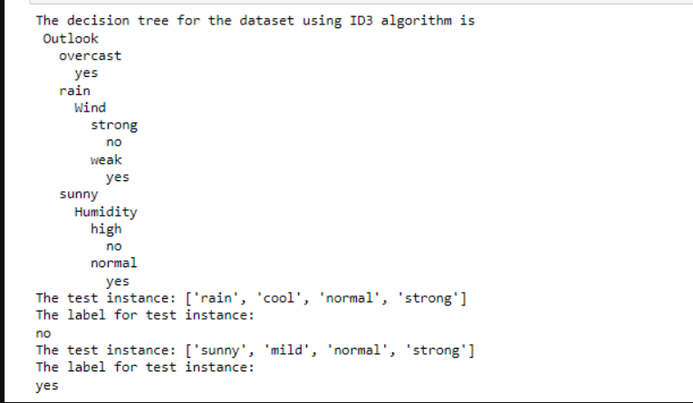

**WEEK 4**

**LINEAR REGRESSION**

**import** numpy **as** np

**import** matplotlib.pyplot **as** plt

**import** pandas **as** pd

dataset **=** pd**.**read_csv('salary_data.csv')

X **=** dataset**.**iloc[:, :**-**1]**.**values

y **=** dataset**.**iloc[:, 1]**.**values

**from** sklearn.model_selection **import** train_test_split

X_train, X_test, y_train, y_test **=** train_test_split(X, y, test_size**=**1**/**3, random_state**=**0)

*# Fitting Simple Linear Regression to the Training set*

**from** sklearn.linear_model **import** LinearRegression

regressor **=** LinearRegression()

regressor**.**fit(X_train, y_train)

*# Predicting the Test set results*

y_pred **=** regressor**.**predict(X_test)

*# Visualizing the Training set results*

viz_train **=** plt

viz_train**.**scatter(X_train, y_train, color**=**'red')

viz_train**.**plot(X_train, regressor**.**predict(X_train), color**=**'blue')

viz_train**.**title('Salary VS Experience (Training set)')

viz_train**.**xlabel('Year of Experience')

viz_train**.**ylabel('Salary')

viz_train**.**show()

*# Visualizing the Test set results*

viz_test **=** plt

viz_test**.**scatter(X_test, y_test, color**=**'red')

viz_test**.**plot(X_train, regressor**.**predict(X_train), color**=**'blue')

viz_test**.**title('Salary VS Experience (Test set)')

viz_test**.**xlabel('Year of Experience')

viz_test**.**ylabel('Salary')

viz_test**.**show()

**OUTPUT**

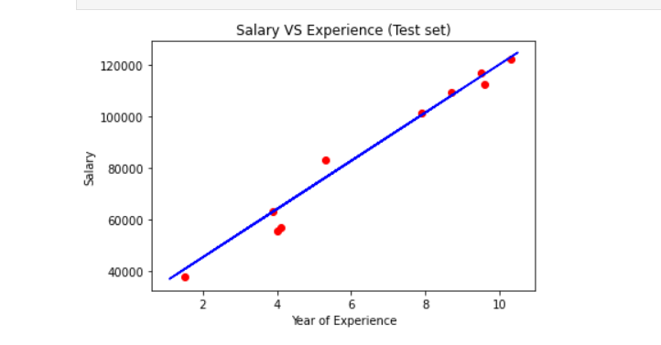

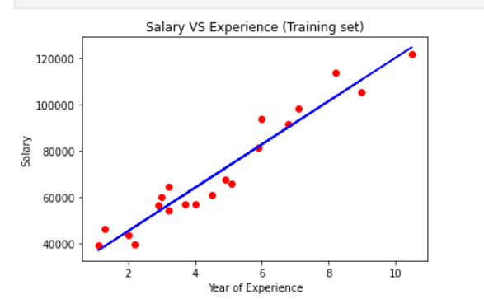

**LAB 5**

**NAÏVE BAYES NETWORK**

**import** pandas **as** pd

**from** sklearn.model_selection **import** train_test_split

**from** sklearn.naive_bayes **import** GaussianNB

**from** sklearn **import** metrics

df **=** pd**.**read_csv(r"C:\Users\admin\Downloads\data5.csv")

col_names **=** ['num_preg', 'glucose_conc', 'diastolic_bp', 'thickness', 'insulin', 'bmi', 'diab_pred', 'age']

predicted_class **=** ['diabetes']

X **=** df[col_names]**.**values

y **=** df[predicted_class]**.**values

print(df**.**head)

xtrain,xtest,ytrain,ytest**=**train_test_split(X,y,test_size**=**0.4)

print ('\n the total number of Training Data :',ytrain**.**shape)

print ('\n the total number of Test Data :',ytest**.**shape)

clf **=** GaussianNB()**.**fit(xtrain,ytrain**.**ravel())

predicted **=** clf**.**predict(xtest)

predictTestData**=** clf**.**predict([[6,148,72,35,0,33.6,0.627,50]])

print('\n Confusion matrix')

print(metrics**.**confusion_matrix(ytest,predicted))

print('\n Accuracy of the classifier is',metrics**.**accuracy_score(ytest,predicted))

print('\n The value of Precision', metrics**.**precision_score(ytest,predicted))

print('\n The value of Recall', metrics**.**recall_score(ytest,predicted))

print("Predicted Value for individual Test Data:", predictTestData)

